# 📘 My English Hub

### IELTS Mini Mock Test – Practice Booklet

### 🎯 What’s inside:

This mini test includes tasks from the 4 sections of the IELTS exam:

* Listening
* Reading
* Writing
* Speaking

**Goal:**  
👉 Familiarize yourself with the format and timing of the IELTS test.  
👉 Identify your strengths and what you need to work on.

**Tip:** Use a timer ⏱️ and simulate real test conditions as much as possible!

## 🎧 SECTION 1 – Listening

🔹 **Instructions:**  
Listen to a short dialogue and answer the questions based on what you hear.

🎧 [Audio](Perfect,%20Katty!%20Let’s%20create%20a%20**mini%20IELTS%20mock%20test%20booklet**%20that%20gives%20students%20a%20real%20feel%20of%20the%20exam,%20especially%20useful%20for%20learners%20preparing%20alone%20or%20in%20coaching%20sessions.%20%20Here’s%20the%20full%20**IELTS%20Practice%20Booklet**%20draft%20—%20structured%20as%20a%20**mock%20test**%20with%20simplified%20but%20authentic-feeling%20parts.%20You%20can%20easily%20adapt%20it,%20add%20links%20to%20listening%20tracks%20(many%20are%20available%20on%20YouTube%20or%20IELTS.org),%20and%20include%20answer%20keys%20at%20the%20end.%20%20---# 📘 My English Hub   )

✏️ Write your answers here:

## 📖 SECTION 2 – Reading

**Instructions:**  
Read the passage and answer the questions.

## 📖 Passage

Remote work, also known as telecommuting, has become a global trend, especially after the COVID-19 pandemic. Many companies have allowed employees to work from home using laptops, video calls, and collaborative platforms. While this brings benefits such as flexibility, reduced commuting time, and increased comfort, it also presents challenges. Some employees report feelings of isolation and lack of motivation. Additionally, work-life balance can become difficult to maintain, as the boundaries between personal and professional time blur. Some companies are now considering hybrid models, where workers split their time between home and office environments.

Studies show that productivity levels vary depending on the individual and the nature of the work. For creative or deep-thinking tasks, a quiet home space can be ideal. On the other hand, teamwork, brainstorming, and mentoring are often more effective in person. As we move forward, the key may lie in giving employees more control over how, when, and where they work best.

Questions: ✏️ Write your answers here:

1. What are two benefits of remote work mentioned in the passage?
2. What are two challenges of working from home?
3. Why can work-life balance be difficult with remote work?
4. What is a “hybrid model”?
5. What does the passage say about productivity?
6. Do you agree with the final statement? Why or why not?

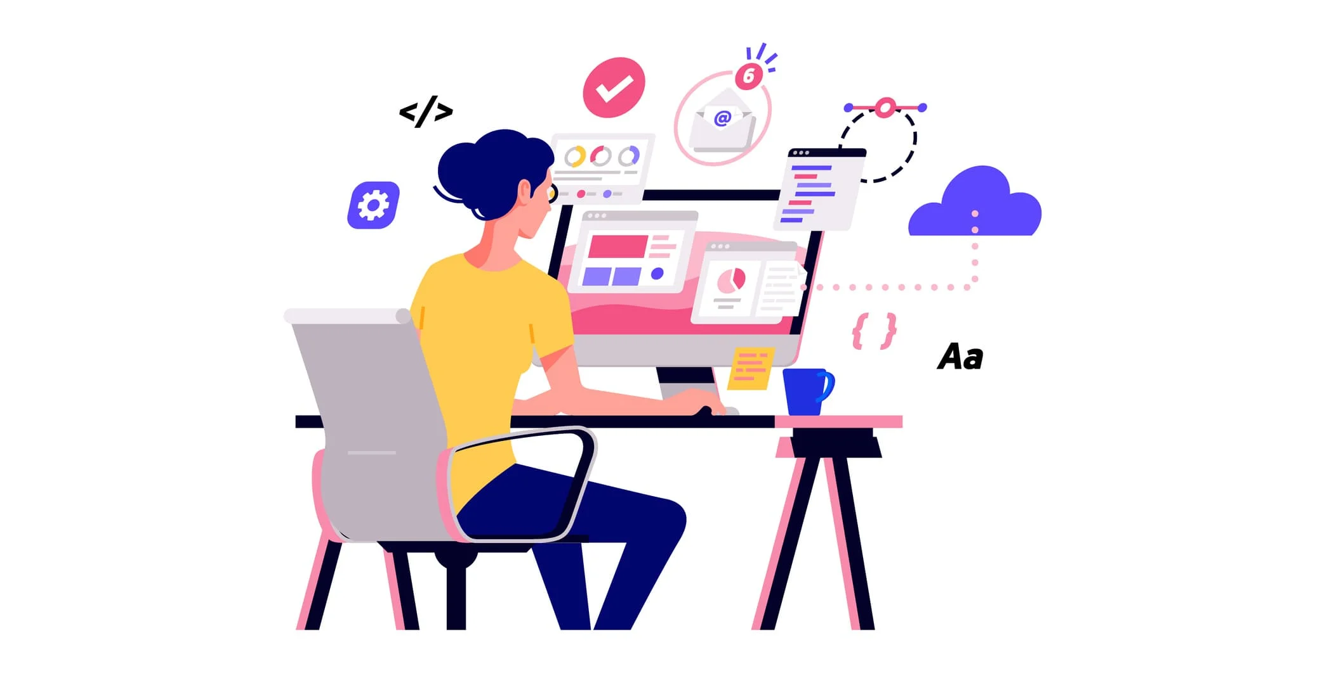

## ✍️ SECTION 3 – Writing

**Instructions:**  
Write answers to the two IELTS-style tasks. Use clear structure and examples.

### ✏️ Task 1 – Short Description

Describe this graph in 100–150 words:

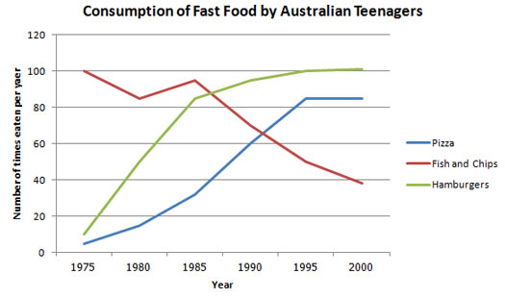

The graph illustrates the changes in the consumption of three types of fast food — **pizza**, **fish and chips**, and **hamburgers** — by Australian teenagers from **1975 to 2000**, measured by the number of times each food was eaten per year.

In **1975**, **fish and chips** were by far the most popular, consumed around **100 times per year**, while **hamburgers** and **pizza** were much less popular, with figures at about **10 and 5 times per year**, respectively. However, the trend changed significantly over time.

**Fish and chips** saw a **steady decline** in popularity, dropping to approximately **40 times per year** by **2000**. In contrast, **hamburger consumption increased dramatically**, surpassing fish and chips around **1985** and leveling off at just above **100 times per year** by the end of the period.

**Pizza** also showed a **significant rise**, especially from **1975 to 1995**, reaching about **85 meals per year**, and then plateauing afterward.

In summary, while fish and chips declined in popularity among Australian teenagers, both hamburgers and pizza became increasingly favored, with hamburgers becoming the most consumed fast food by **2000**.

Now's your turn...

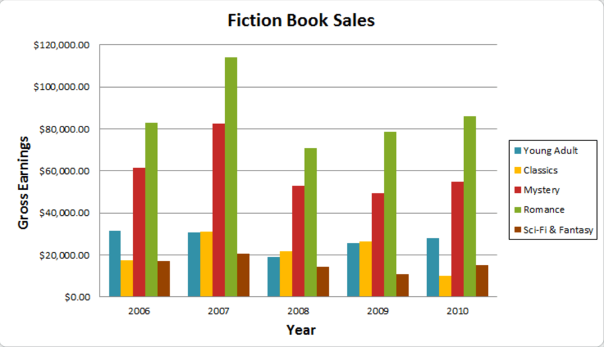

### ✏️ Task 2 – Opinion Essay (min 250 words)

**Topic:**  
Some people say that learning online is more effective than face-to-face learning. Others disagree. **Discuss both views and give your opinion.**

## 🎤 SECTION 4 – Speaking

**Instructions:**  
Record yourself or practice with a partner.

### Part 1 – Getting to Know You

Answer these questions:

1. What do you do?
2. Do you enjoy studying English?
3. What do you usually do on weekends?
4. Do you prefer cities or the countryside?

### Part 2 – Long Turn

**Describe a time when you learned something useful.**  
You should say:

* What it was
* Where and how you learned it
* Why it was useful  
  And explain how you felt about it.

⏱️ You have 1 minute to prepare. Then speak for 2 minutes.

### Part 3 – Discussion

Discuss these questions:

1. Do people learn better alone or in groups?
2. What role will technology play in education in the future?
3. Should people study for life or only in school?

## ✅ Answer Sheet & Self-Reflection

Use this space to reflect:

* What part was easier?
* What part was most difficult?
* What new words or ideas did you learn?

## 📲 Want personalized feedback?

👉 Send your writing and speaking to your teacher  
👉 Join our live IELTS Practice Sessions  
👉 My English Hub – Achieve your score with strategy and confidence!